NNI is looking forward to another great year serving the Northland. We are excited to host our first Senior Workshop of 2016, January 13th, at 9:00. Our guest speaker, Clay County Sherriff Paul C. Voscovo, III will be discussing various programs offered through the Clay County Sheriff Department. Did you know that the safety programs offered through the sheriff’s department are free to Clay County Residents? To learn more about these programs contact the Sheriff’s Office 816-407-3765. You may also visit their website www.claymosheriff.org which features many helpful links to outside resources related to public safety.
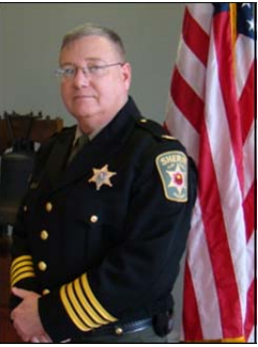

Public Safety
Kansas City:
Police Department :
Non –Emergency 816-234-51111
Shoal Creek 816-413-3400
North Patrol 816-437-6200
Gladstone:
Non-Emergency 816-436-3550
Public Safety 816-436-2200 ext. 4097
Clay County Sherriff:
Non –Emergency 816-407-700
Office 816-407-3750
Platte County Sherriff:
Non –Emergency 816-858-3521
Office 816-858-2424

