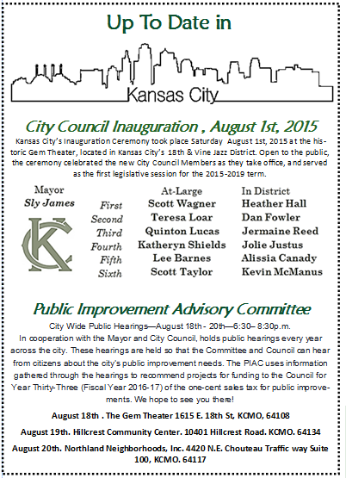

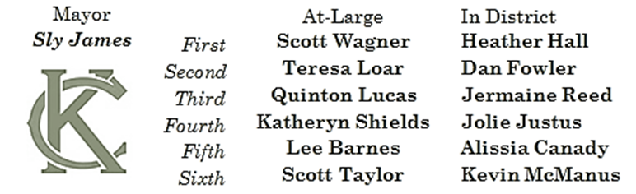

City Council Inauguration , August 1st, 2015
Kansas City’s Inauguration Ceremony took place Saturday August 1st, 2015 at the historic Gem Theater, located in Kansas City’s 18th & Vine Jazz District. Open to the public, the ceremony celebrated the new City Council Members as they take office, and served as the first legislative session for the 2015-2019 term.
Public Improvement Advisory Committee
City Wide Public Hearings—August 18th - 20th—6:30– 8:30p.m.
In cooperation with the Mayor and City Council, holds public hearings every year across the city. These hearings are held so that the Committee and Council can hear from citizens about the city’s public improvement needs. The PIAC uses information gathered through the hearings to recommend projects for funding to the Council for Year Thirty-Three (Fiscal Year 2016-17) of the one-cent sales tax for public improvements. We hope to see you there!
August 18th . The Gem Theater 1615 E. 18th St, KCMO, 64108
August 19th. Hillcrest Community Center. 10401 Hillcrest Road. KCMO. 64134
August 20th. Northland Neighborhoods, Inc. 4420 N.E. Chouteau Traffic way Suite 100, KCMO. 64117

